**Health Hub Medical Clinic**

**1.Project Introduction**

Introduction to the " Health Hub Medical Clinic " project.

Objectives and goals of the project.

**1.1 project overview**

The Health Hub Medical Clinic project aims to establish a modern healthcare facility, leveraging innovative technologies and a patient-centric approach. The clinic will offer a wide range of medical services, including primary care, specialist consultations, diagnostics, and preventive health programs. The clinic's vision is to provide accessible, high-quality healthcare to the community, promoting overall well-being and early disease detection

**1.2 Purpose**

The purpose of the Health Hub Medical Clinic is to address the growing healthcare needs of the community. It will offer a convenient and integrated healthcare experience, fostering health awareness and disease prevention. By leveraging digital health solutions, the clinic will enhance patient engagement and data-driven decision-making, improving healthcare outcomes.

**2. Problem Definition and Design Thinking**

**2.1 Empathy Map**

**2.2 Ideation and Brainstorm**

**3. Result**

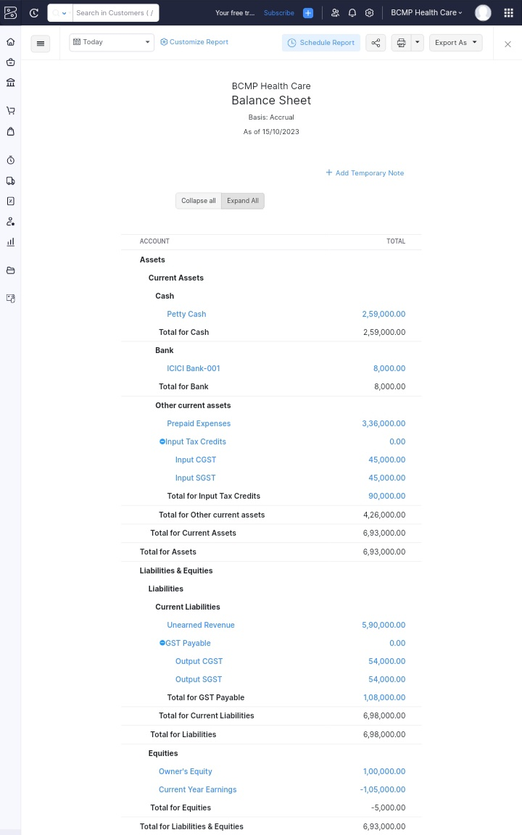

**4. Advantages and Disadvantages**

Advantages:

* Convenient and comprehensive healthcare services.
* Integration of digital health technologies for efficient patient management.
* Focus on preventive care and early disease detection.
* Improved access to healthcare for the community.

Disadvantages:

* Initial setup costs and technology integration challenges.
* The need for continuous training and adaptation to evolving healthcare technologies.
* Potential data security and privacy concerns associated with digital health.

**5.Applications**

The Health Hub Medical Clinic can serve as a model for modern healthcare delivery in the digital age. Its applications include:

Providing a blueprint for integrating digital health solutions into traditional healthcare settings.

Demonstrating the benefits of patient-centered care and preventive health initiatives.

Offering a scalable approach for healthcare facilities in other regions.

**6. Conclusion**

This program had been successfully executed.

**7. Future Scope**

Zoho develpement is going to focus on cloud service.

**8. Appendix**

A. Source code

https://github.com/ PARKAVI-BHARATHI/HEALTH